Pollinator Conservation
The most recognized pollinators are bees, butterflies, moths, insects and birds. Pollinators are essential to our environment as evidenced by their role in the reproduction of over 85% of the world’s flowering plants, including more than two-thirds of the world’s crop species. Additionally, fruits and seeds derived from insect pollination are a major part of the diet of approximately 25% of all birds and mammals. The loss of natural habitat, pesticide usage and diseases threaten our eco-system endangering pollinators and ultimately, life on our planet. When planning your spring garden, consider incorporating native plants including some varieties of pollinator-preferred plants. Learn more at http://www.xerces.org . A list of pollinator plants for this area can be found at:
http://www.xerces.org/wp-content/uploads/2014/09/MidwestPlantList_web.pdf
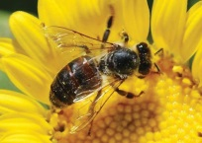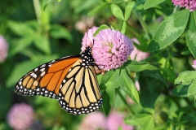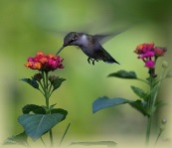

Plant Native Milkweed to Aid the Monarch Migration
The mountain range in Michoacan, Mexico is where all the monarchs from the U.S. and Canada east of the Rockies spend the winter after migrating hundreds, often thousands of miles. Milkweed is essential for the butterflies because it is the only food of monarch caterpillars. Welcome the return of the monarchs by planting native milkweed, untreated by pesticides.
Not all milkweed is alike: it is very important that you plant the species of milkweed native to your area and that you do not buy it from vendors who pre-treat it with pesticides. If you can’t plant this spring, you can also plant milkweed seed this fall to aid next spring’s migration. You can even plant milkweed in a pot or planter box. http://www.monarchwatch.org/milkweed/prop.htm
http://www.wildearthguardians.org
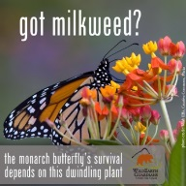
Upcoming Native Plant Sales:
http://www.lcfpd.org/plantsale/
http://www.conservelakecounty.org/native-plant-sale

